**CENTENNIAL COLLEGE**

**COMP 228: JAVA PROGRAMMING**

**FINAL LAB TEST (Version 3)**

**Full Marks: 100**

**Maximum Allowable Time: 4 hours**

Student’s Name: Aryan Patel

ID: 301226774

**Please read the following instructions before you do anything:**

You **must submit 2** **documents** in the drop box titled FinalLabTest.

1. **MS Word document:**

**[IN THE BEGINNING OF THIS DOCUMENT, YOU MUST PROVIDE A SCREEN SHOT OF THE TIME YOU START TO WRITE CODE AND AT THE END, YOU MUST PROVIDE A SCREEN SHOT OF THE TIME YOU ENDED AND SUBMITTED THE WORD DOCUMENT.]**

**Use this document to provide screen shots and code. DO NOT DELETE the Question.**

You should take screen shots of the application followed by the complete code that you would use to develop this application. **The screen shots should represent the full functionality of your application.**

You must **COPY the code used from the code window and paste the entire code into this Word document AFTER the screen shots. Do not provide screen shots of your code since it is hard to read screen shots of the code window.**

**DO NOT zip the Word document.**

**DO NOT submit in any file format other than MS Word document.**

1. **The Java zipped application:**

Submit yourcomplete **zipped Java application folder** in the same drop box.

##### Exercise 1

Start a new Eclipse Java project. Name the project: **YourFullName_COMP228TestFall2016**. For example: JohnSmith_COMP228TestFall2016. **DO NOT** create a package in this project. Let Eclipse create the default package.

Write a GUI application in Java that allows user to select students by their city.

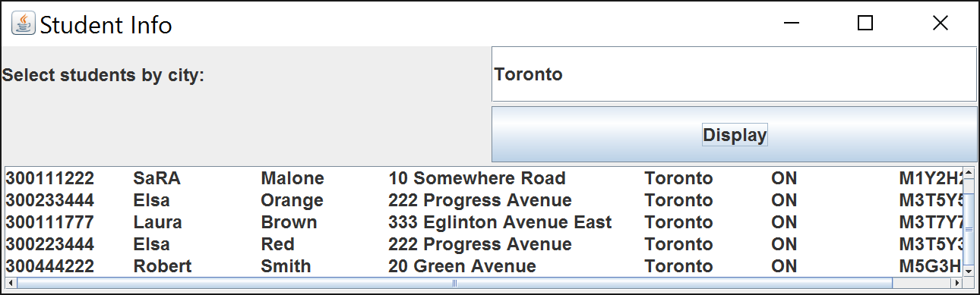

The user should be able to enter the *city*. The application should retrieve the student information from an Oracle table named **Student**. Here is the definition of the table:

CREATE TABLE Students (

studentID char(9) NOT NULL,

firstName varchar (20) NOT NULL,

lastName varchar (20) NOT NULL,

address varchar (30) NOT NULL,

city varchar(30) NOT NULL,

province char(2) NOT NULL,

postalCode char(6) NOT NULL,

PRIMARY KEY (studentID)

);

Populate the table with several rows as below:

insert into Students values('300111222','Sam', 'Malone', '10 Somewhere Road', 'Toronto','ON','M1Y2H2');

commit;

The information should be displayed in a JTextArea component which has scrolling abilities. Use “\t” and “\n” to format the display.

Use the most appropriate layout manager classes to implement the layout of this GUI. (100 marks)

Main class

**package** application;

**import** javafx.application.Application;

**import** javafx.fxml.FXMLLoader;

**import** javafx.stage.Stage;

**import** javafx.scene.Scene;

**import** javafx.scene.layout.AnchorPane;

**public** **class** Main **extends** Application {

@Override

**public** **void** start(Stage primaryStage) {

**try** {

//BorderPane root = new BorderPane();

AnchorPane root = (AnchorPane)FXMLLoader.*load*(getClass().getResource("Main.fxml"));

Scene scene = **new** Scene(root);

scene.getStylesheets().add(getClass().getResource("application.css").toExternalForm());

primaryStage.setTitle("Player Registration");

primaryStage.setScene(scene);

primaryStage.show();

} **catch**(Exception e) {

e.printStackTrace();

}

}

**public** **static** **void** main(String[] args) {

*launch*(args);

}

}

Student class

**package** application;

**public** **class** Student {

**private** String studentID ;

**private** String firstName ;

**private** String lastName ;

**private** String address ;

**private** String city;

**private** String province;

**private** String postalCode;

**public** String getStudentID() {

**return** studentID;

}

**public** **void** setStudentID(String studentID) {

**this**.studentID = studentID;

}

**public** String getFirstName() {

**return** firstName;

}

**public** **void** setFirstName(String firstName) {

**this**.firstName = firstName;

}

**public** String getLastName() {

**return** lastName;

}

**public** **void** setLastName(String lastName) {

**this**.lastName = lastName;

}

**public** String getAddress() {

**return** address;

}

**public** **void** setAddress(String address) {

**this**.address = address;

}

**public** String getCity() {

**return** city;

}

**public** **void** setCity(String city) {

**this**.city = city;

}

**public** String getProvince() {

**return** province;

}

**public** **void** setProvince(String province) {

**this**.province = province;

}

**public** String getPostalCode() {

**return** postalCode;

}

**public** **void** setPostalCode(String postalCode) {

**this**.postalCode = postalCode;

}

**public** Student(String studentID, String firstName, String lastName, String address, String city, String province, String postalCode) {

**super**();

**this**.studentID = studentID;

**this**.firstName = firstName;

**this**.lastName = lastName;

**this**.address = address;

**this**.city = city;

**this**.province = province;

**this**.postalCode = postalCode;

}

**public** Student() {

// **TODO** Auto-generated constructor stub

}

}

Database connection

**package** application;

**import** java.sql.Connection;

**import** java.sql.DriverManager;

**import** java.sql.ResultSet;

**import** java.sql.SQLException;

**import** java.sql.Statement;

**import** java.util.ArrayList;

**import** java.util.List;

**public** **class** DatabaseConnection {

**private** Connection connection;

ResultSet rs;

**private** **static** **final** String ***DRIVER*** = "oracle.jdbc.driver.OracleDriver";

**private** **static** **final** String ***DATABASE_URL*** = "jdbc:oracle:thin:@199.212.26.208:1521:SQLD";

**private** **static** **final** String ***USER_ID*** = "COMP214_W22_zor_67";

**private** **static** **final** String ***PASSWORD*** = "password";

**public** List<Student> displayStudentInfo(String cityName) {

List<Student> students = **new** ArrayList<Student>();

**try** {

Class.*forName*(***DRIVER***);

connection = DriverManager.*getConnection*(***DATABASE_URL***, ***USER_ID***, ***PASSWORD***);

Statement statement = connection.createStatement();

rs = statement.executeQuery("select studentID, firstName, lastName, address, city, province, postalCode "

+ " from Students where city = '" + cityName.trim() + "'");

**while** (rs.next()) {

Student student = **new** Student(rs.getString("studentID"), rs.getString("firstName"),

rs.getString("lastName"), rs.getString("address"), rs.getString("city"),

rs.getString("province"), rs.getString("postalCode"));

students.add(student);

}

} **catch** (SQLException | ClassNotFoundException e) {

e.printStackTrace();

}

**return** students;

}

}

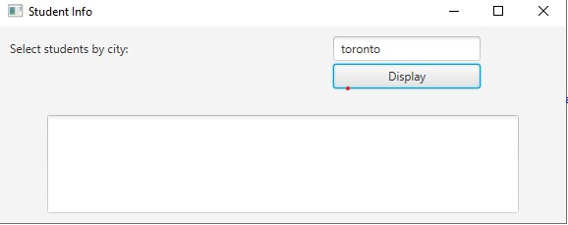

**Evaluation:**

|  |  |
| --- | --- |
| **Functionality** |  |
| Correct implementation of UI (using SWING or JavaFX components, event handling) | 35% |
| Correct implementation of data access using JDBC (connecting with server, executing a prepared statement, displaying results) | 50% |
| Comments, correct naming of variables, methods, classes, etc. | 5% |
| **Friendly input/output** | 10% |
| **Total** | 100% |